git 分支管理

https://www.liaoxuefeng.com/wiki/0013739516305929606dd18361248578c67b8067c8c017b000/0013743862006503a1c5b

f5a783434581661a3cc2084efa000

Git都把每次提交串成一条时间线，这条时间线就是一个分支。只有一条时间线时，这个分支叫主分支，即master分支。master指向提交，HEAD指向master，就是当前分支。
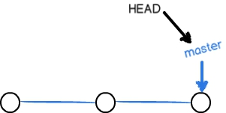

创建并切换分支

$ git checkout -b dev //创建dev分支，然后切换到dev分支

Switched to a new branch 'dev' git checkout命令加上-b参数表示创建并切换，相当于以下两条命令：

$ git branch dev //创建dev分支

$ git checkout dev //切换到dev分支

Switched to branch 'dev'
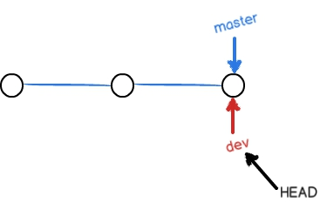

查看分支

$ git branch //列出所有分支，当前分支前面会标一个*号。

* dev master

从现在开始，对工作区的修改和提交就是针对dev分支了。对readme.txt做个修改，然后提交。
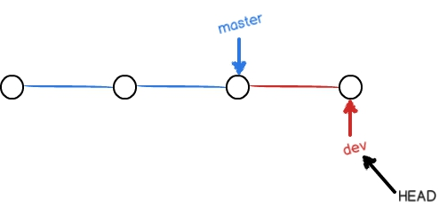

切换分支

$ git checkout master //切换回master分支

Switched to branch 'master'
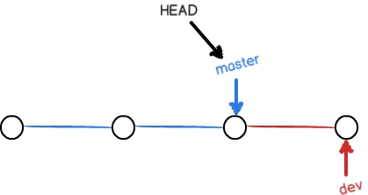

合并分支

$ git merge dev //把指定的dev分支的工作成果合并到当前分支master分支上

Updating d17efd8..fec145a

Fast-forward

readme.txt | 1 +

1 file changed, 1 insertion(+)
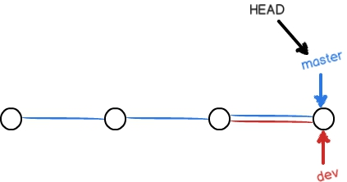

删除分支

$ git branch -d dev //删除dev分支

Deleted branch dev (was fec145a).
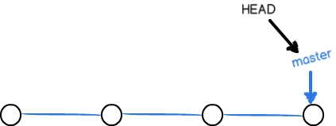

解决冲突

创建新的feature1分支后，在master分支和feature1分支各自都分别有新的提交
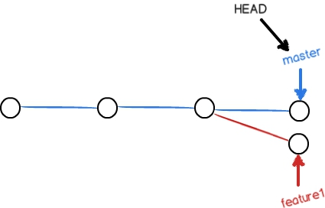

此时合并就可能会有冲突

$ git merge feature1 Auto-merging readme.txt
CONFLICT (content): Merge conflict in readme.txt

Automatic merge failed; fix conflicts and then commit the result.
git status也可以告诉我们冲突的文件

$ git status

- On branch master

- Your branch is ahead of 'origin/master' by 2 commits.

- Unmerged paths:

- (use "git add/rm <file>..." as appropriate to mark resolution)

- both modified:readme.txt

#

no changes added to commit (use "git add" and/or "git commit -a")

直接查看readme.txt的内容

Git用<<<<<<<，=======，>>>>>>>标记出不同分支的内容 Git is a distributed version control system.

Git is free software distributed under the GPL. Git has a mutable index called stage.
Git tracks changes of files.

<<<<<<< HEAD

Creating a new branch is quick & simple.

=======

Creating a new branch is quick AND simple.

>>>>>>> feature1

修改后保存再提交：

$ git add readme.txt

$ git commit -m "conflict fixed" [master 59bc1cb] conflict fixed
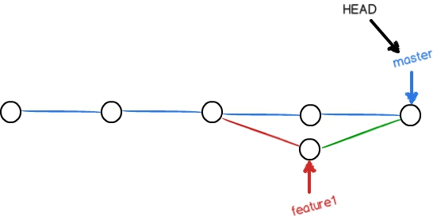

用带参数的git log也可以看到分支的合并情况：

$ git log --graph --pretty=oneline --abbrev-commit

- 59bc1cb conflict fixed

|\

| * 75a857c AND simple

- | 400b400 & simple

|/

* fec145a branch test

...

最后，删除feature1分支。

